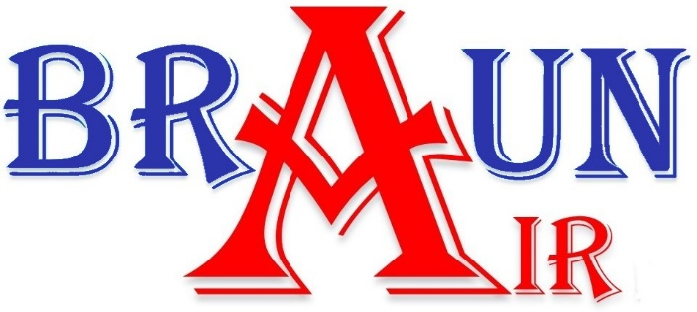
License #: TACLA83475C
Commercial Maintenance Contract Options

Option 1 includes (2) visits bi-annually. Option 2 includes (4) visits Quarterly.

- Option 1 (1-year Contract)
- Inspection and Coil Cleaning Option.
  - Inspection Includes:
    - Run test system in cool/heat cycle for summer/winter inspection.
      - Record refrigerant pressures and temperatures
      - Record temperature split of evaporator coil.
      - Record amp draws of all Mechanical components and verifies according to manufacture spec with data tag.
      - Provide written results to the customer with an efficiency score and recommended repairs with quotes if any.
  - Coil Cleaning Includes:
    - Thoroughly clean condenser coil once a year.
    - Basic chemical cleaning of evaporator coil once a year.
    - Blow out drain line twice a year including a no-clog guarantee.
    - Insert pan tabs in evaporator drain pan. (kills any potential growth and deodorizes supply air)
  - Benefits:
    - While under contract service call fee is waived. ($24.99 value)
    - While under contract, a 15 % discount on parts is applied to any repairs needed.
  - Pricing: $174.99/year for the 1st system and $99.99/year for each additional system.

Terms and Conditions: Unpredicted failures and/or “acts of God” are not warranted by Braun Air during or following an Inspection. A 24-hour notice must be given in advance if scheduling conflict occurs or a service fee may apply. No other warranties are expressed or implied unless written in writing by Braun Air, LLC.
- Option 2 (1-year Contract)
- Inspection, Coil Cleaning, Filter and Belt Change Option.
  - Inspection Includes:
- Run test system in cool/heat cycle for summer/winter inspection.
      - Record refrigerant pressures and temperatures
      - Record temperature split of evaporator coil.
      - Record amp draws of all Mechanical components and verifies according to manufacture spec with data tag.
      - Provide written results to the customer with an efficiency score and recommended repairs with quotes if any.
  - Coil Cleaning Includes:
    - Thoroughly clean condenser coil once a year.
    - Basic chemical cleaning of evaporator coil once a year.
    - Blow out drain line twice a year including a no-clog guarantee.
    - Insert pan tabs in evaporator drain pan. (kills any potential growth and deodorizes supply air)
  - Belt and Filter Change Includes:
    - One Belt Change per year with spare always left on site
    - (4) quarterly Visits to replace filters with pleated MERV 8 rating or better.
  - Benefits:
    - While under contract service call fee is waived. ($24.99 value)
    - While under contract, a 15 % discount on parts is applied to any repairs needed.
  - Pricing: $249.99/year for the First system and $124.99/year for each additional system.

